ИИН 840220402320
⁠87024977446
ТУЛЕГЕНОВА Жанат Нагметовна,
Шамалған ауылындағы орта мектебінің ағылшын тілі пәні мұғалімі.
Алматы облысы, Қарасай ауданы

TRAVEL TO KNOWLEDGELAND
Learning objectives(s) that this lesson is contributing to: | 5.3.5.1 interact with peers to negotiate, agree and organise priorities.
Lesson objectives: | Widen learners’ knowledge and develop speaking skills
Pl
Part of the lesson/Time | Teacher’s activity | Student’s activity | Assessment | Resources
Beginning of the lesson  Team work  3 мин. | Organization moment :  1.Greeting.  2. Organization moment. Give them different images of English speaking countries to divide into 2 groups  I- Eagle  II – Falcon  In differentiation part «Flexible pace learning» method was used to give students a choice in order to make them interested in learning process. | Learners greet and reply  Aim: to develop learners’ speaking skills and create friendly atmosphere | At the organization moment T tries to motivate active learners. to collect as many eagles and falcons as possible  Method “Fast reaction” | Pictures with images of Eagle and Falcon  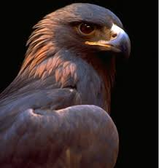  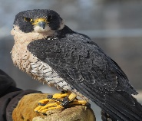
Middle of the lesson  Presentation part.  Team work.  10min | Part 1:  Teacher gives the globes with pictures in it to each team  Part: 2  “Break a brain” method. Teacher gives proverbs in two languages.  Part:3.  “Think, find and seek” method  Teacher gives each team QR with riddles in it  Part 4.  “Watching video” method  Teacher shows video and gives test.  Part 5.  “Antonyms” method  Teacher gives task on the WhiteBoard. | Learners have to use pictures and the world globes to introduce their team.  Learners have to match them by their meanings  Students have to solve the riddle and give the answer in three languages.  Learners watch and do the test.  Learners drag and drop each keyboard next to each antonyms. | Descriptor:  Encourage Ss who can find countries that is connected with new lesson.  Choose the right answer  give correct answer  Remember the information and answer the questions  Matching opposite words in two minutes | Globes  Pictures  Stickers    Class Tools    QR    WhiteBoard  You Tube  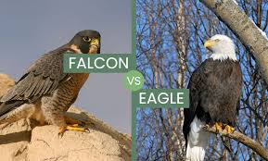  WhiteBoard  Wordwall  
End of the lesson.  Reflection  Individual work  5 min | Teacher counts the birds of each team.  Eagle and Falcon. | Learners use smiles to show their knowledge according to the lesson  Green- I understood  Yellow-I have some questions  Red-I need a help.  Efficiency: Ss can use colors to show how much do they remember.  Differentiation: «Conclusion» method is used to finish the lesson. | Learners evaluate each other and encourage classmate with phrases like:  Well done! Brilliant! Good job! I like it! | Whiteboard  

